Convert XML File into Json File Format.

**DRIVER CLASS:**

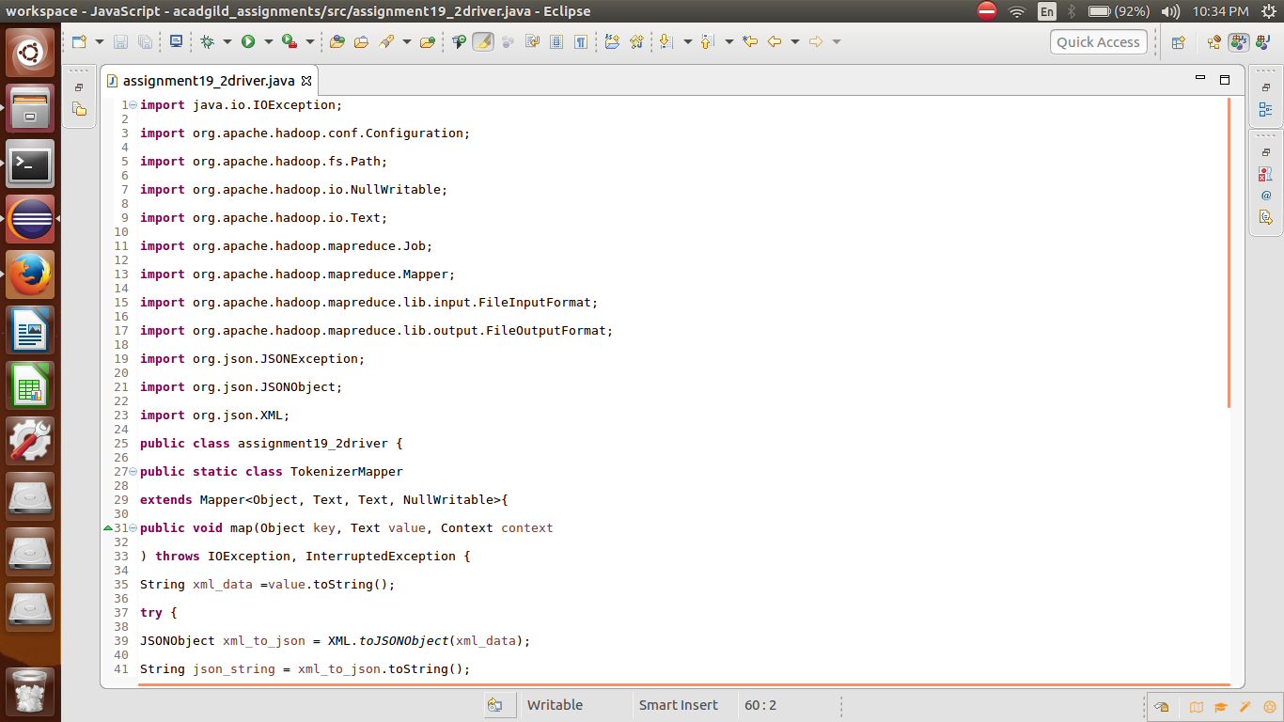

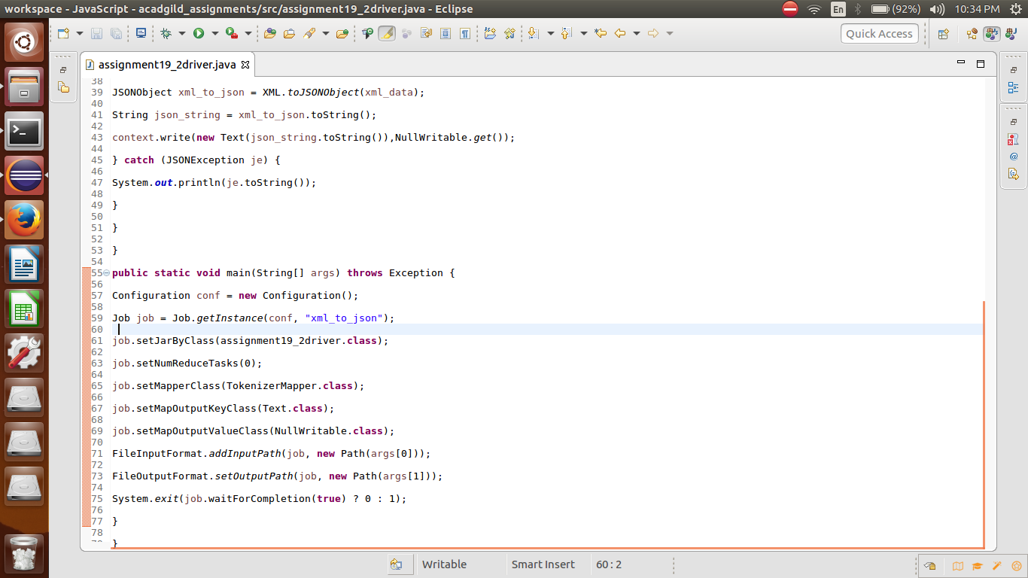

**INPUT FILE:**

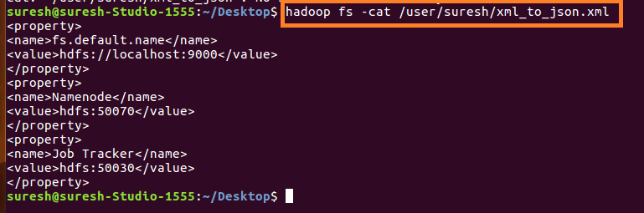

**RUNNING JAR:**

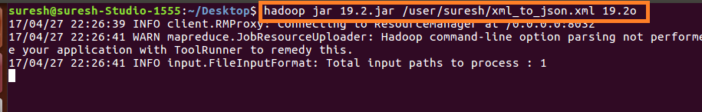

**OUTPUT:**

